RSPCA West Hatch update:

The team at West Hatch are working hard and making plans for 2024. We have employed a new Grounds Person to assist with the 23 acres and to focus on creating a new conservation habitat management plan for the site- this will include taking ecological surveys to find out more about the species we have on site, as well as creating some additional habitats such as bee banks and wildflower meadows to help support the local biodiversity.

We will be looking at leading some nature walks around the centre’s meadows and woodland to talk about the different butterfly, bird and other species found here- local residents will be invited so we will be in touch once all of the details have been confirmed!

We will also be arranging some local tours around the site and inviting people to come and learn about the work we do here. Our Education Team will be joining us to look into arranging some local events on site.

The new centre manager Kayla Terry is always available to listen to any concerns raised by the local community so please do feel free to reach out if you need to.

Some recent good news stories:

‘Dave’ the Hedgehog was admitted recently. He was named by the member of the public that found him that had a very severe case of ringworm and it was really touch and go for this little guy. With amazing veterinary treatment and TLC from the team Dave is on his way to recovery. The members of the public that brought him in have kept in regular contact and are keen to release him back in their garden once he is up to weight.

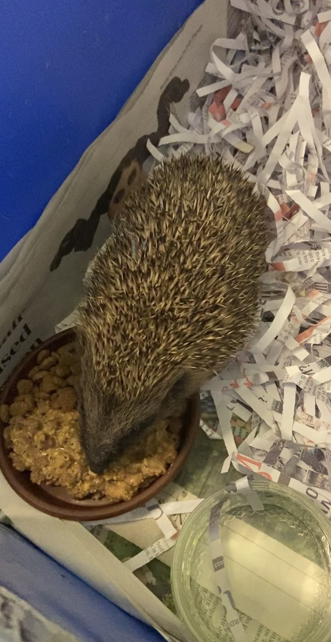

We have recently had two small dormice admitted to the centre. We reached out to The Wildwood Devon who provide amazing natural habitats and these 2 went off to contribute to the ongoing conservation of dormice, as they are now down by 51% in 20 years!

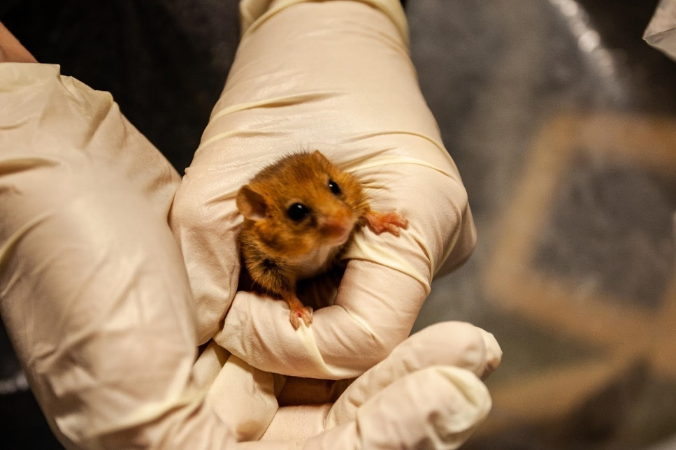

Seal season is coming to an end now and we are busy arranging releases for a large number of seals still in our care. The hospital unit was full of seals through the early winter with both Grey and Common seal pups- they are now reaching the end of their rehabilitation journey and we will be waving them off!
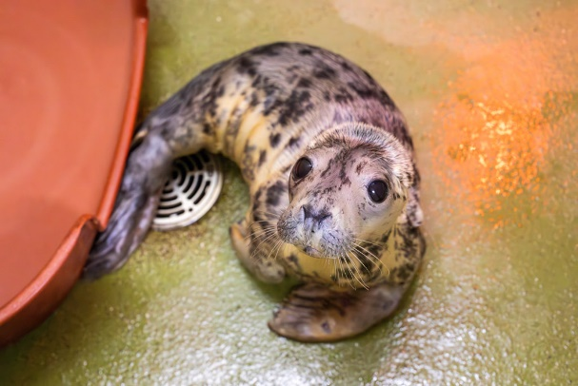

Beavers

West Hatch has had the rare experience of having two 2nd year juvenile Beavers brought into their care. We are so pleased we were able to help this amazing species in their time of need and these have now been released in their found location.

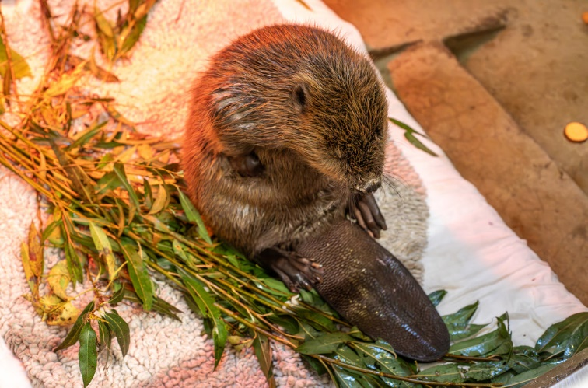

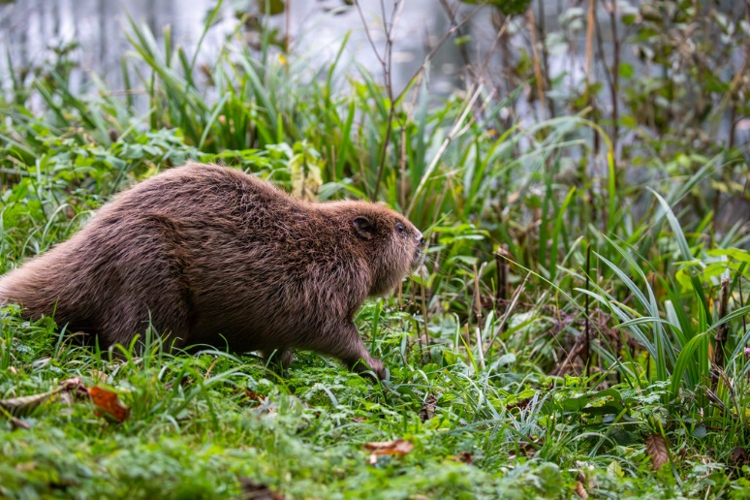

Total number of wildlife animals admitted into the centre 2023 (as of December 1st)- 1319

Top ten species:
Hedgehog 364
Wood pigeon- 131
Grey Seal- 65
Rabbit- 50
House martins- 47
Blackbird- 47
Feral- 46
Carrion Crow- 45
Red fox- 43
Jackdaw- 34

West Hatch Animal Centre December 23

The companion animal side has also been extremely busy with ups and downs throughout the year. We had helped a huge number of animals including dogs, cats, pigs, goats, rabbits and even some African Pygmy Hedgehogs!
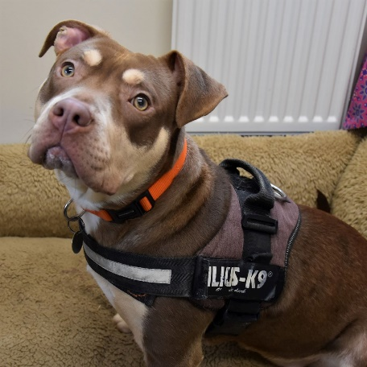
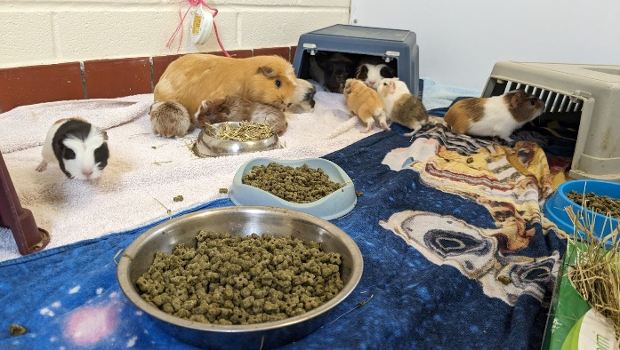

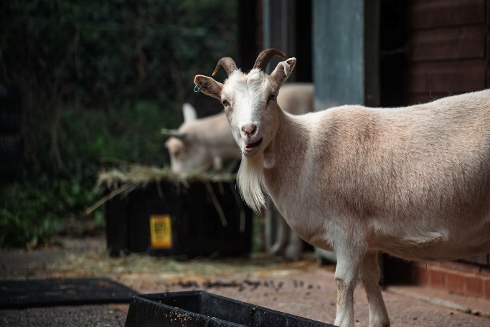
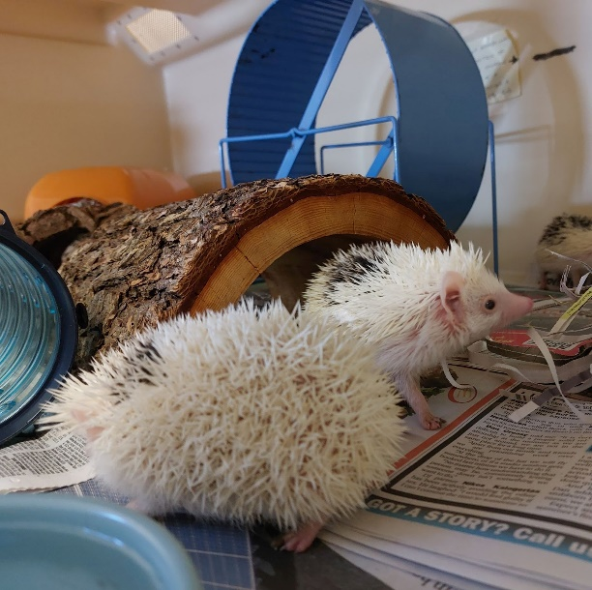

During 2023 we admitted: 436 animals- including:

97 dogs
160 cats
56 rabbits
34 guinea pigs
39 small furries
22 birds
10 Farm animals (goats/ sheep/ pigs)
5 Fish
8 Reptiles
5 Pygmy hedgehogs

