

Get in touch

**In an emergency always call 999**

**For non-emergency matters call us on 101** or report online via [www.avonandsomerset.police.uk/  
report](http://www.avonandsomerset.police.uk/report)

**To report a crime anonymously,** contact Crimestoppers on   
0800 555 111 or visit

[www.crimestoppers-uk.org](http://www.crimestoppers-uk.org)

Keep up to date

Facebook and Twitter are a great way to keep up to date with your local Neighbourhood Policing team. Follow us on:

**Facebook:** Taunton Neighbourhood Policing

**Twitter:** @ASPWestSom

[www.avonandsomerset.police.uk](http://www.avonandsomerset.police.uk)

NEWS FROM THE BEAT

We would like to continue to encourage everyone to have lights on timers in your properties, especially as the clocks have now the nights draw in.

Please be mindful of leaving Christmas gifts on show.

We are now in a period of Operation TONIC whereby increased staff will be out and about randomly stopping vehicles and conducting roadside breath tests / drugs tests with a view to reducing the numbers of drink / drug driving.

The team have had increased reports regarding inconsiderate / illegal parking whereby vehicle users are parking on footpaths causing pedestrians to have to walk into the highway. Any such reports could result in your vehicle being removed / towed away and / or a fixed penalty notice issued.

November 2022

**NEWS IN YOUR AREA**

**Taunton East**

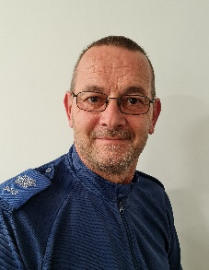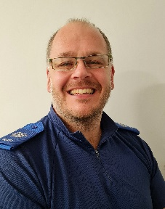

Meet the Team

Hi! We are PCSOs Tony and Steve and we cover Taunton East. Community is at the heart of our policing and we want to know about any issues and problems to make sure everyone is safe and feels safe. We are often out and about in the community so please do come and have a chat when you see us.

COMMUNITY SPEED WATCH

Many thanks to ALL the teams from the beat area who continue to give up their time to help our communities. We continue to be as supportive as we can when operational commitments allow. If you would like to join a CSW team, then please view our website and follow the CSW links.

Please follow the below link to find your crime statistics for your local area

<https://www.police.uk/pu/your-area>

**LINK TO LOCAL CRIME STATISTICS**

**LOCAL PRIORITIES**

Rural Crime

There have been reports of sheep attacks by dogs and theft of livestock.

It is the responsibility of the owner to always keep their dog under control.

ASB and underage drinking

At this point in time, we have had very few reports of ASB. We will however pay increased attention to the park areas during the festive period, when operational commitments allow**.**

Did you know…?

**You can now use the Street Safe online tool to anonymously report locations where you feel unsafe**

These reports provide insight that help to shape local policing and make the streets safer for everyone.

Street Safe is a pilot service for anyone to anonymously tell us about public places where you have felt or feel unsafe, because of environmental issues, e.g. street lighting, abandoned buildings or vandalism and/or because of some behaviours, e.g. being followed or verbally abused.

Please note: 'Street Safe' is not for reporting crime or incidents.

Visit [www.police.uk/pu/notices/streetsafe/street-safe/](http://www.police.uk/pu/notices/streetsafe/street-safe/) for more information