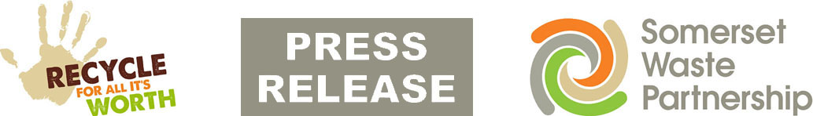

19 June 2020

Recycling sites: ‘shop-style’ social distancing on its way

Visitors to Somerset Waste Partnership’s recycling centres will find ‘shop-style’ social distancing arrangements in place over the next week.

Floor markings and other extra signs are being introduced to all 16 sites in the coming days. The set-up will be similar to that seen in supermarkets and other shops, with visitors expected to take responsibility for keeping themselves and others safe.

Sites were closed in March in response to COVID-19 and reopened in May with extra staff and barriers on hand to make sure social distancing was followed and to control access to waste skips.

This extra staffing has been gradually phased out and over the course of the next week, starting on Saturday (20 June), barriers will be removed.

Other safety and access restrictions remain in place:
- Gloves to be worn when outside the vehicle
- Maximum of two people per household
- Trailers and 3.5 tonne vans only allowed between 4pm and 6pm on weekdays
- Lifting assistance not available.

There will be a further update when all sites can take the last few materials currently not being accepted, including glass and cardboard which can be recycled at the kerbside.

Sites have experienced long queues at times, especially in the morning, and the public is still advised to only make trips to the tip if really necessary.

Mickey Green, Managing Director of SWP, said: “These arrangements will be familiar to everyone from their trips to the supermarket, with the responsibility very much on the public to do the right thing and maintain social distance.

“The way that visitors have accepted the restrictions and followed the guidance so far has been great and I’m sure this will be no different.”

All sites are now open for their usual summer hours. Queue cams are operating for Bridgwater, Chard, Highbridge, Minehead, Street, Taunton, Wells and Yeovil. Please check before you leave
www.somersetwaste.gov.uk/recycling-centre-queue-cams/

For more information about how to reduce and reuse your waste, visit www.somersetwaste.gov.uk

For the latest information about services and any disruption visit www.somersetwaste.gov.uk/coronavirus and follow @somersetwaste on Twitter and Facebook.

[END]
Notes to editors

Somerset Waste Partnership manages waste services for all councils in Somerset.

Media contacts:
Somerset Waste Partnership
Nick Cater, Senior Communications Officer Nick Cater,
Nicholas.Cater@somersetwaste.gov.uk

Mark Ford, Head of Communications and Engagement, 07977412198 mford@somersetwaste.gov.uk

