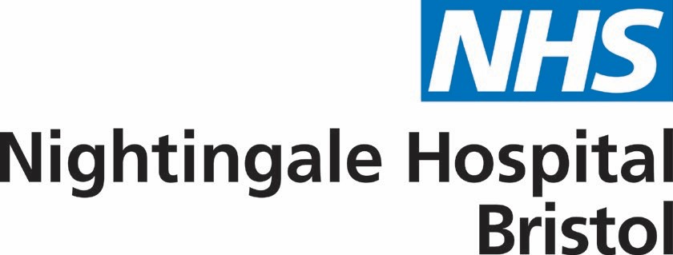

england.bristolnightingalecomms@nhs.net
10 April 2020

Dear colleague

It’s just over a week since we started work on the NHS Nightingale Hospital Bristol and what a week it has been.

Yesterday we held our first Programme Board which was a very positive experience. The progress we have made in the past week has been little short of phenomenal. We could not have moved at such pace without you, our partners and stakeholders, and we are very grateful for your continued support and commitment to partnership working.

Our NHS Nightingale Hospital Bristol belongs to you and is being built by your ideas, your people and your passion for caring for those who are most in need. It is a legacy for our future, not only in terms of the lives we hope to save but also in working together with respect, kindness and shared purpose.

We’ve put together the attached story to share with you who we are, why we are here and how we fit into your network. I hope you find it informative and interesting.

Thank you once again for your continued support.

Kind regards

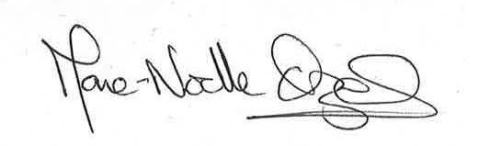

Marie-Noelle Orzel
Chief Officer

